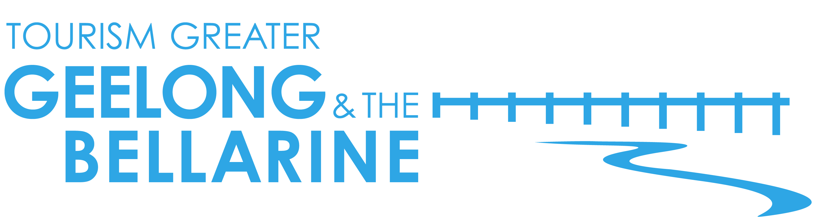
28 October 2016

Reasons to visit The Bellarine in 2017

The Bellarine Peninsula in Victoria was this week recognised as one of the world’s best value destinations by Lonely Planet in their annual Best in Travel 2017 listing.

Known locally as ‘The Bellarine’, the peninsula extends past Geelong, hugging Port Phillip Bay from Portarlington around to Ocean Grove and Barwon Heads. Located an easy 90 minute drive from Melbourne, The Bellarine is easily accessible from either Melbourne or Avalon Airports, or a ferry ride away from the Mornington Peninsula with Searoad Ferries.

Surrounded by water and with the Barwon River winding through it, this beautiful pocket of Victoria is rich in local produce and is home to boutique wineries, vibrant seaside villages, beautiful beaches and plenty of activities.

Lonely Planet has recognised the area as quickly gaining a reputation as a great value, must-visit destination. Here are just a few reasons why The Bellarine should be added to your travel list in 2017;

Tasty local produce – The Bellarine is a gourmet delight, with abundant local produce found at every turn. The easiest way to discover the best the region has to offer is by exploring the Bellarine Taste Trail, which boasts over 40 unique experiences. Stop by one of the many restaurants and cafés, where growers and suppliers work collaboratively with local chefs to deliver menus which showcase the local, seasonal produce. Or buy direct from the growers and makers themselves. Enjoy mussels served fresh and plump and straight off the boat at Advance Mussel Supply, multi award-winning cheese at Drysdale Cheeses, olive oil at Lighthouse and Manzanillo or freshly picked blueberries at Tuckerberry Hill. Be sure to squeeze in a wine tasting or two at one of the many boutique wineries, along with a visit to the The Bellarine’s very own cidery – Flying Brick Cider House.

Breathtaking natural scenery - The Bellarine is a destination that is easy on the eyes, with stunning views across Port Phillip Bay towards Melbourne, spectacular coastal vistas and rolling vineyards littering the landscape. Jack Rabbit Vineyard and Terindah Estate are two must visit wineries which boast breathtaking views of the Bay, Basils Farm has equally impressive views of Swan Bay across to Queenscliff. Stunning coastal scenery can also be enjoyed by exploring one of many coastal walks. Top picks include the beachside hike from Point Lonsdale right up to the mouth of the Barwon River at Barwon Heads, or the six kilometre coastal walk from Queenscliff to Point Lonsdale.

Charming coastal villages – The Bellarine’s vibrant seaside villages pulse with activity every summer as Melburnians flock to the area to enjoy the local beaches and relaxed pace of life. Barwon Heads is famous for its trendy main street lined with gourmet cafés and designer shops. Historic Queenscliff is home to grand old hotels, beautiful architecture, fascinating maritime museums and boutique shopping. Point Lonsdale is enviably located at the entrance to Port Phillip Bay with stunning lighthouse views and is the perfect location for alfresco dining, while family favourite Ocean Grove boasts a relaxed coastal vibe and a beautiful white, sandy beach.

Adventures for the whole family – All members of the family are spoilt for choice on The Bellarine with an impressive number of activities to choose from. On the water, you can learn about the rich maritime history of the region while enjoying close encounters with aquatic animals aboard a South Bay Eco Adventures tour, swim with dolphins with See All Dolphin Swims, learn to surf with Go Ride a Wave or try your hand at canoeing, kayaking or stand up paddle boarding with Paddle Life Barwon Heads. Back on land, popular activities on offer include horse riding, mini golf, bike riding, segway tours, sky-diving, scenic and aerobatic flights and the ever popular Adventure Park – the largest theme park in Victoria.

Vibrant calendar of events – Year-round The Bellarine boasts an action packed calendar of events. It’s a seafood feast at the annual Portarlington Mussel Festival, while the regions wineries showcase their best during the Winter Shiraz Weekend and Toast to the Coast. Cycling fans line the streets for the Cadel Evans Great Ocean Road Race, now a designated UCI world tour event, which pedals through Cadel’s home town of Barwon Heads. Lovers of all things Celtic migrate to Portarlington for the annual National Celtic Festival and music fans from near and far enjoy the Queenscliff Music Festival. Also in Queenscliff, The Blues Train keeps visitors entertained as they enjoy one of Australia’s most unique music experiences aboard an historic steam train.

Outstanding public golf courses – The Bellarine is a golfer’s paradise, boasting four outstanding public courses which are consistently rated as some of the best in Australia. Take your pick from Curlewis Golf Club, Barwon Heads Golf Club, or one of the two courses at Thirteenth Beach Golf Links which hosts the Vic Open Golf Championships. Add golf courses in Portarlington and Point Lonsdale to the impressive list of courses on offer and you will see golfers truly are spoilt for choice in this part of the world.

Amazing beaches – All summer long, visitors flock to The Bellarine to enjoy the region’s beautiful beaches. Families can take advantage of the pristine sand and gentle waves at the Ocean Grove main beach, considered one of the safest in Victoria. The mouth of the Barwon River in Barwon Heads is the ideal location for paddling in the shallow water and exploring rock pools. Lesser known but equally impressive beaches include the family friendly bay at Portarlington and locals favourite Breamlea beach. Surfing is also popular, with Thirteenth Beach and Raffs Beach two of the most sought after locations.

High quality, affordable accommodation – The Bellarine is home to an impressive collection of holiday and caravan parks which boast first class facilities and a wide range of accommodation options. Popular options include Big4 Beacon Resort, Big4 Bellarine Holiday Park and Barwon Heads Caravan Park. For those looking for something with all the bells and whistles, you will also find a large number of boutique properties, Bed & Breakfasts and resort style accommodation offerings.

For further information go to www.visitgeelongbellarine.com.au. A selection of high resolution images are available via drop box here.

<ENDS>

For additional high resolution imagery or if you are interested in finding out more about Tourism Greater Geelong & The Bellarine’s familiarisation program please contact:

Madeleine Blake | Gemini Communications | 0400 262 505 |
madeleine@geminicommsconsulting.com.au

Narelle Needham |Tourism Greater Geelong & The Bellarine | 0412 677 397 |
nneedham@tourismgeelongbellarine.com.au

