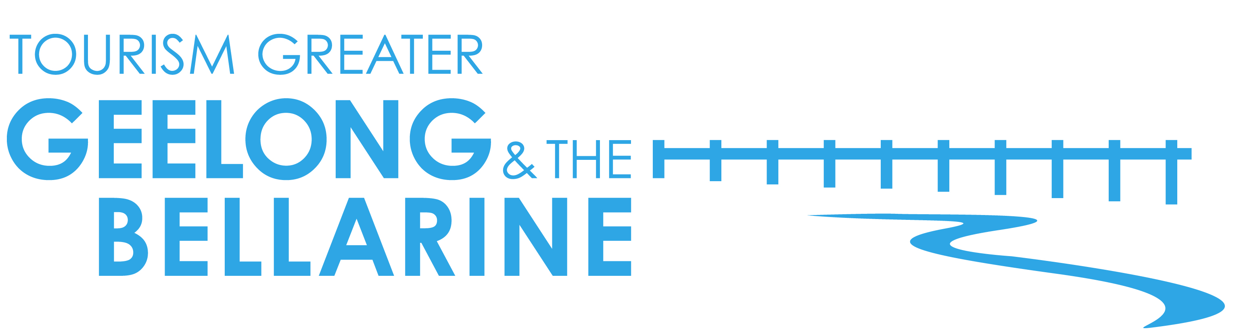
16 August, 2017
Geelong’s on the up and reinventing itself

Manufacturing and industry have been synonymous with Geelong, but with many big employers moving away or closing down, the city is reinventing itself and re-emerging as a cultural hub. Locals are injecting life and re-purposing many of the city’s disused buildings, creating eclectic and exciting spaces. Old woollen mills, mechanics workshops and even an old technical school are amongst a swag of historic buildings that have been given a new lease of life. The cultural vibe of Geelong continues to grow with the emergence of innovative and creative spaces.
Some of the key refurbished buildings include:

Little Creatures and White Rabbit Brewery
The giant Valley Worsted Woollen Mill in Swanston Street Geelong was purchased by the eclectic Little Creatures brewery in 2011. Outgrowing their west coast digs, they needed an east coast home, with a Creatures feel, to add to their brewing repertoire. In 2013 the first Geelong-brewed Pale Ale was produced and in 2016 its sister brewery – White Rabbit – moved in, relocating from Healesville. The enormous former wool mills site, which dates back to 1923, has been transformed into a hipster haven and family friendly enclave, featuring an epic canteen, provedore, locally brewed beverages and brewery tours through the facility.

The Old Paper Mills, Fyansford
This historic 19th Century industrial site hugging the banks of the Barwon River is now home to a variety of art galleries, artist studios, cafes and cellar doors. The Door Gallery and Café operates from the 1870’s building offering visitors a quirky café and wine bar combined with an Indian antique door gallery. Provenance Wines will soon open an onsite winery and function centre providing an old-world riverside wine and eatery must-stop.

Devlin Apartments
The transformation of the former Gordon Junior Technical School Building into 4.5 star luxury accommodation has been nothing short of extraordinary. Originally constructed in 1926 housing thousands of aspiring Geelong students, Devlin Apartments is a fine example of the Georgian Revival style. The building has maintained its heritage exterior and inside has been converted into 27 fully self contained luxury apartments and 10 motel style rooms, ranging from The New Yorker, The Industrialist to The Modernist. The splendour of the past has been captured throughout the building by way of superior architecture and interior design features, complimented by historical images in the public areas.

King of the Castle Café
Located in trendy Pakington Street Geelong West, the café’s polished concrete floors add to the industrial atmosphere of the space of what was formerly a run-down panel beater shop, and prior to that a mechanics workshop. Before King of the Castle opened its doors to deliver great coffee and beautifully prepared food, the site was derelict for more than a decade. The expansive dining hall with rustic-chic decor, offers padre coffee, gelato stand, Pana Chocolate cakes and a full range menu from the health conscious to the indulgent.
Boom Gallery
Located just off Pakington Street near the Barwon River in Newtown, is a vibrant contemporary art and design gallery housed in an historic woollen mill. The work of emerging and established artists is presented at Boom Gallery which has an onsite café, events space, stockroom and jewellery gallery. It is one of the city’s most dynamic galleries. Launched in 2011, Boom helped set the tone for the region’s appreciation of its historic buildings.

The Federal
The enormous Federal Woollen Mills site in North Geelong is fast becoming a unique commercial hub. The once derelict space is an icon of the city’s industrial past that has been restored and transformed into commercial spaces. The precinct currently houses The Federal – a new café and bar fitted out in 1920s style décor plus a range of other innovative and creative businesses.

Piknik

Housed in a converted Golden Fleece roadhouse, Piknik sources local Bellarine produce at the onsite café and sells a range of jams and preserves. The café is filled with rustic wooden tables and the old workshop area is opened on the weekends to create more space with communal tables made from recycled bowling alleys. The chefs embrace local and seasonal produce and the menu is constantly changing. Piknik is a unique licenced cafe restaurant and pantry at the heart of the Bellarine Taste Trail.

For a dropbox of images of Geelong’s revitalised buildings see
http://bit.ly/2sRkMZH

For further information on Geelong and the Bellarine go to www.visitgeelongbellarine.com.au

<ENDS>

For high resolution imagery or if you are interested in finding out more about Tourism Greater Geelong & The Bellarine’s familiarisation program please contact:

Ingrid Sanders | Gemini Communications | 0408 112 728 | ingrid@geminicommsconsulting.com.au

Narelle Needham |Tourism Greater Geelong & The Bellarine | 0412 677 397 |
nneedham@tourismgeelongbellarine.com.au

