Membership

POLICIES & PROCEDURES

2023
Contents

1. Introduction 3
2. Definitions 4
2.1. Tourism Greater Geelong and The Bellarine Region 4
2.2. Individual Brochures 4
2.3. Co-operative Brochures 4
2.4. Regional Information Periodicals 4
2.5. Community Flyers/Pamphlets 4
2.6. Commercial Flyers/Pamphlets 4
2.7. Accredited Visitor Information Centres 4
3. Membership Rates 5
3.1. Membership Fees 5
3.2. Subscription Members 5
3.3. New Members 5
4. Visitor Information Centres 6
4.1. Member’s Brochures 6
4.2. Co-operative Brochures 6
4.3. Out of Region Brochures 7
4.4. Community Event Flyers/Pamphlets 7
4.5. Commercial Event Flyers/Pamphlets 7
5. Administration 8
5.1. Payment of Membership and Joining TGGB 8
5.2. Administration Procedures of Membership Fees 8
5.3. Membership Refunds 8
5.4. Cancellation of Membership 8
5.5. Complaints 9
5.6. Fees & Charges 9
5.7. Membership Levels and Associated Benefits 10
5.8. Business Events Geelong and Tourism Membership Benefits 11
5.9. Membership Benefit Guidelines 11

Membership Policies
- Introduction
The following membership policies and guidelines have been developed to outline specific deliverables and rules of tourism membership with Tourism Greater Geelong and The Bellarine (TGGB). Several membership levels are offered to ensure all sectors of the local tourism industry and the community have the opportunity to participate in the marketing and promotion of our region.

In order to be a member of TGGB, the business needs to fall under one of these categories:

tourism related associations;

tourism related businesses; or
1.1.3. businesses providing services to the tourism industry.

Definitions
This section defines the key terms used in this document.

Tourism Greater Geelong and The Bellarine Region
The TGGB region includes the municipalities of the:

- City of Greater Geelong;
- Borough of Queenscliffe; and
- Golden Plains Shire from the southern boundary as far north as Meredith.

More detailed information on the structure is contained in the TGGB Strategic Business Plan, TGGB Statement of Rules and Purposes and on the corporate website at www.tourismgeelongbellarine.com.au

Individual Brochures

An individual brochure is deemed as printed matter, of standard DL size, that clearly promotes a single business, service or facility.

Co-operative Brochures

A co-operative brochure is printed material that advertises separate member businesses, services or facilities, and can contain listings of service businesses. It is a prerequisite that all businesses promoted in the brochure must be a member of TGGB.

Regional Information Periodicals

Regional information periodicals are printed material that contain informative current data, information services, happenings, events and emergency numbers. e.g. What’s On Magazine, Geelong and Surf Coast Living Magazine.

Community Flyers/Pamphlets

Community flyers/pamphlets are printed materials that promote community activities and small one-off events.

Commercial Event Flyers/Pamphlets

Commercial flyers/pamphlets are printed materials that promote commercial events.

Accredited Visitor Information Centres

A Visitor Information Centre (VIC) is a clearly signed, publicly accessible, physical place with personnel providing predominantly free information to facilitate the experiences of tourists and travellers.

Accredited VICs in Victoria are certified by an independent body, Australian Tourism Accreditation Program (Vic), as either Level 1 or Level 2, to ensure high standards are maintained.

Accredited VICs are required to open (where possible) 10am-4pm, 7 days a week, 363 days a year. They must abide by set conditions surrounding business information, legal compliance, human resource management, training, business planning, financial procedures and operational procedures.

Accredited VICs are identified through the internationally recognised ‘i’ trademark.

Membership rates

Membership Fees

Membership fees are to be decided by the member depending on the level they would like access to: -

If a member has two or more businesses situated within the same property under the same ownership and brand; the primary business will be charged the appropriate fee at full cost based on the membership level they have chosen.

A secondary brand under the same ownership has the option to purchase a membership add-on to feature the second brand in marketing opportunities. This includes an online Australian Tourism Data Warehouse (ATDW) listing, a listing in the appropriate printed publication and an additional VIC brochure for $150.00 per annum, payable alongside ordinary membership fees.

If a member’s secondary business is located offsite from their primary business, a separate full priced membership will apply.

If a second business is located onsite but under separate management and/or ownership, a separate full priced membership will apply.

Subscription Members

3.2.1 Subscription members refer to our free level of membership and can be upgraded at any time. These members are entitled to receive our communication to keep up to date with everything that is happening. They can also attend member networking functions, training sessions at an additional cost. This cost will be advertised depending on the event or training session being held.

New Members
    - Upon joining Team Tourism, all members automatically become Subscription Members, which is the free membership level. Direct debit forms and a prospectus will be sent to them, and they will be able to decide if they would like to become a paying member. Someone from the Membership Engagement Team will contact them to discuss this.
    - Once direct debit forms have been completed and returned to TGGB they will become a fully paid-up member and have access to all the benefits of their chosen level.
    - Our preferred method of payment is via quarterly direct debits. Should the business financial operations not allow this alternate arrangements can be discussed, and an annual invoice can be provided.

3.3.4. It is recognised that the business is the ‘member’. If a business is sold the membership automatically transfers to the new owner. No refunds on annual invoices will be given. Quarterly direct debits will cease until contact can be made with new owners. The Membership Engagement Team will make contact with the new owners to transition them to Financial Membership.

Visitor Information Centres (VICs)
The following policies and definitions help to facilitate the brochures and publications displayed in official accredited Visitor Information Centres (VICs) within the TGGB region. As a benefit of financial membership, tourism operators are encouraged to display their brochures. Priority is given to financial members over other publications and material.

Member Brochures

Financial members are entitled to display one brochure. Providing around 500 - 1000 copies to the TGGB office is recommended for region-wide distribution. While the TGGB team will endeavour to ensure brochure stocks are maintained in VICs, members are responsible for providing ample brochure stocks. Accreditation stipulates that VICs must display Victorian Official Visitor Guides. Any other publications must be referred to the TGGB office for assessment.

Each financial member is offered one DL brochure for display in the accredited VICs in the region. This brochure may only contain financial member material (i.e. with no additional non-financial advertisers).

Members should have their own individual brochure rather than joining other businesses to produce a collaborative piece. This avoids issues or clashes with closures, membership payments or other administrative problems.

To be suitable for display in a VIC, financial member brochures must be:
- DL size (1/3 of A4), printed on thick quality paper (210-300+GSM). Vertical makes the most effective display;
- Business name and location is on front of the brochure for easy identification in brochure holders;
- Co-operative brochures will only be displayed if all advertisers are financial members; and
- Quality brochures are preferred. Photocopies are to be avoided.

Our membership and VIS teams can assist with any of the above points, including local printers or examples of great brochures.

Further to 4.1.1, additional business brochures (advertising the one business) may be displayed in VICs at the discretion of TGGB – fees may apply. Secondary brochures from the one member may be displayed in accredited Visitor Information Centres only.

The TGGB team will distribute brochures and endeavour to maintain stocks at accredited VICs across the region. It is the member’s responsibility to ensure adequate stock of their brochures is supplied to the VICs. Members can expect a one-week turnaround from delivery to TGGB to being displayed in VICs. If a faster turnaround is required (e.g. around Christmas) members may drop direct to VICs after discussing with TGGB VIS team.

Co-operative Brochures

It is essential that all advertisers in co-operative brochures are financial members of TGGB for these brochures to be displayed or distributed via official accredited Visitor Information Centres in the region.

If a member becomes non-financial after the co-operative brochure has been produced, all efforts are to be made to encourage the operator to renew their membership. If unsuccessful, the co-operative brochure will be removed from the VICs.

If a member produces a co-operative brochure that includes non-financial members, every effort is to be made to encourage the non-financial member(s) to become financial with TGGB. If the non-financial member declines, the brochure is not distributed.

Out of Region Brochures

Official regional brochures and publications outside the TGGB boundaries will be displayed in line with accreditation guidelines or at the discretion of the VIS Coordinator.

Community Event Flyers/Pamphlets

Community event flyers or pamphlets are permitted for display in official accredited Visitor Information Centres at the discretion of the VIS Coordinator.

These include events from community groups and not-for-profit organisations. Materials are permitted to be displayed for a maximum of one month or for a period at the discretion of the VIC Coordinator. The materials will automatically be removed when the event has occurred.

Commercial Event Flyers/Pamphlets

Commercial event flyers or pamphlets promoting events are encouraged within accredited VICs.

Financial members whose core business is events are encouraged to utilise the DL brochure (defined in 2.2 Individual Brochures) for year-round promotion at VICs. Posters may also be provided to the VICs to be displayed for one month prior to the event.

Financial members may utilise unique, one-off commercial event flyers or pamphlets to promote events. These are permitted for display in accredited VICs, generally utilised for one month in VICs or for a longer period at the VIC Coordinator’s discretion.

The VIS Coordinator will determine if space is available and permitted for non-financial members to display materials at VICs for a maximum period of one month. Discretion must show that the event being promoted is appropriate, benefits the community or visitor economy and that financial members will be given priority.

Administration
The centralised membership database for the TGGB region is managed and maintained by the TGGB office and is updated regularly to ensure all members appear on the database. At the time of applying for a membership, the prospective member must complete and submit an online ‘Join Us’ form. The Membership Engagement Team will then make contact with the prospective member to discuss their membership.

Payment of Membership and Joining TGGB

Membership applications and payments are forwarded directly to the Membership Engagement Team for processing on a quarterly payment structure.

Administration Procedures of Membership Fees
On receipt of completed application forms and payments, the following procedures are to be undertaken by TGGB:

The member is added to the membership database and an email is sent to all Tourism Greater Geelong and The Bellarine staff to advise them of the new member. Following this notice, and if applicable, Visitor Information Centre staff will ensure the new member’s brochures are on display. A cover letter, membership sticker, certificate and any other relevant information is forwarded to the member to acknowledge their membership with TGGB.

TGGB hold 100% of all membership fee revenue for marketing, promotional and industry development activity conducted by the Regional Tourism Organisation (RTO).

Membership Refunds
Membership with TGGB is non-refundable.

If a business is sold the membership transfers to the new owner and no refund is applicable.
5.3.2 The member is to let the Membership Engagement Team know in writing if they would like to cancel their quarterly direct debits.

Cancellation of Membership
Any cancellation or suspension of membership due to misconduct, or prejudice to the interests of the association, shall be dealt with under section 2.9 of the Statement of Purposes and Rules of Tourism Greater Geelong and The Bellarine Incorporated.
5.4.1 If the operator chooses to not continue with their membership, then they will be moved to the free Subscription membership level (unless specified otherwise) and receive communication only.

This includes the removal of brochures from the region’s accredited Visitor Information Centres and deletion of business listing(s) on any relevant websites.

5.4.2 If the operator chooses to then re-join as a member of TGGB within the next 12 months there will be a $100.00 re-joining fee.

5.4.3 Hardship Clause

5.4.3.1 TGGB will consider individual hardship circumstances in consultation with affected members.

5.4.3.2 The Membership Engagement Team, in consultation with the Executive Director, may offer up to 2 quarters of membership fee relief for a member facing financial hardship.

5.4.3.3 Hardship will only be granted once within a membership lifespan.

5.4.3.4 Any member wishing to invoke the hardship fee relief must have been a financial member for a minimum of 12 months prior to the application.

5.4.3.5 A confidential application should be made in writing to TGGB Membership at info@tourismgeelongbellarine.com.au

Complaints
If TGGB receives a verbal complaint from either a member or visitor regarding TGGB or a member of the RTO and the issue cannot be dealt with on a one-to-one basis, the complainant will be asked to express the complaint in writing. The Executive Director of TGGB will then investigate the nature of the complaint through verbal and / or written communications. Copies of correspondence will be forwarded to relevant people and/or associations.

If TGGB receives a complaint from either a member or visitor regarding the Visitor Information Centres, the matter will be addressed according to the Visitor Information Servicing guidelines.

Should a complaint be received from or relating to a municipality member (e.g. Borough of Queenscliffe, City of Greater Geelong) regarding a tourism-related matter, the Executive Director of TGGB will be responsible for managing this complaint.

Fees & Charges

TGGB manages the payment of GST on membership fees. Membership is inclusive of GST.

TGGB offer businesses the opportunity to buy-in throughout the year on a pro-rata basis. If they join in the middle of a quarter, they will become a member from the day they return their completed direct debit forms and their first payment will be debited on the next payment run. If the member requires an invoice, this will be based on the number of quarters left in the calendar year.

Membership Levels and Associated Benefits
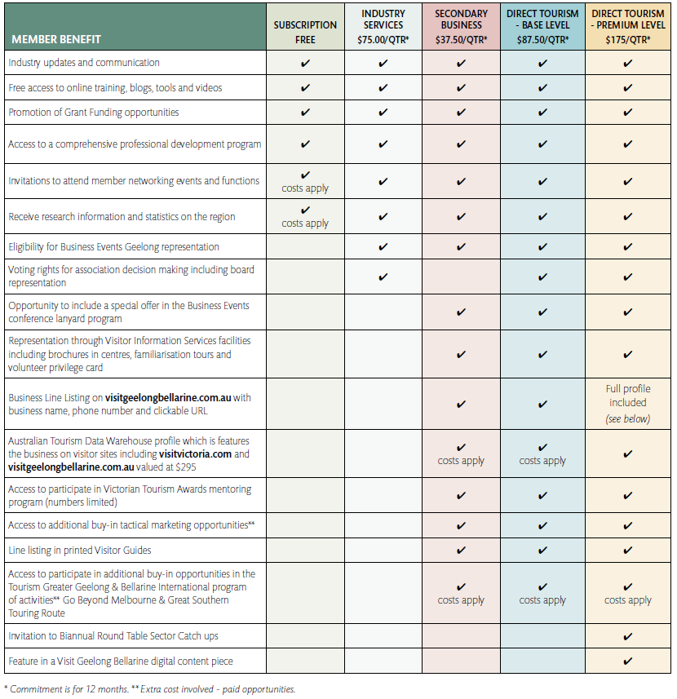

Business Events Geelong Membership Benefits
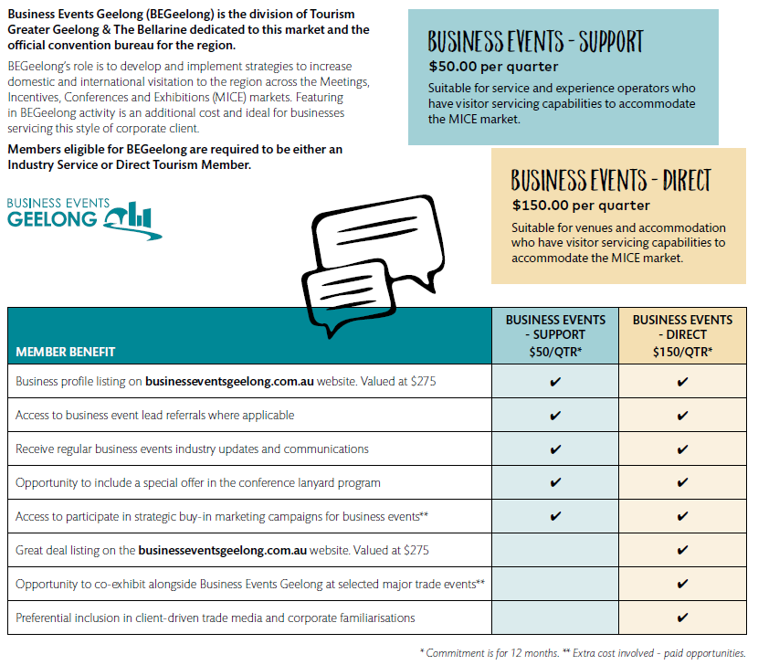

Business Events Geelong and Tourism Membership Benefits

Access to professional development sessions.

Unless otherwise specified, businesses paying for their membership are entitled to have 2 staff members attend all professional development sessions free of charge.

Businesses at a Subscription membership level can have 2 staff members attend at 100% of the true cost to attend.
5.9.1.3 Business with no membership to Tourism Greater Geelong and The Bellarine are able to have staff attend professional development sessions at a recommended cost per person if space permits.

Access to tourism and networking functions.
5.9.2.1 All paying members are entitled to have 2 staff members attend networking functions and tourism forums conducted by TGGB free of charge. Additional staff may be permitted at the discretion of TGGB for an extra cost $25 per person. Occasionally a small fee may apply to attend networking events such as the conference or Christmas function. On occasions restrictions may apply.
5.9.2.2 Subscription members can have 2 staff attend networking functions for a fee of $50.00 per person.

Eligible for TGGB media, social media and public relations (PR) activities.

Only financial members of TGGB will be considered for marketing and PR opportunities. Businesses are featured at the discretion of TGGB marketing staff in line with the content marketing strategy focus on experiences and destinations. Premium Members of TGGB have the benefit of being guaranteed to feature in one piece of Visit Geelong Bellarine digital content.

TGGB’s discretion will be used in selecting and pitching media ideas, based on best meeting the brief and criteria of the publication or broadcaster concerned.
5.9.3.3 Members are encouraged to communicate with relevant TGGB staff to keep the organisation informed of news, developments and story angles.

Online presence on official local and state tourism websites.

Eligible members are entitled to a profile listing in the Australian Tourism Data Warehouse (ATDW) which feeds Visit Victoria, Australia.com and Visit Geelong Bellarine.

Participants must comply with the standards as set by Visit Victoria and ATDW.

It is the responsibility of the member to set up, manage and maintain the profile listing and its contents to ensure accuracy and relevance

Promotion of grant funding opportunities.

If available and deemed relevant, eligible members will be made aware of and provided information on grant funding opportunities.

Information on Victorian Tourism Awards support.

Eligible members of tourism will be provided with access to forums conducted to offer support and training in preparing a submission for the Victorian Tourism Awards.

5.9.7 Visitor Information Centre volunteer familiarisation tour eligibility.
5.9.7.1 Financial members may be considered for VIC volunteer familiarisation tours.
5.9.7.2 Due to time and capacity constraints, this opportunity cannot be guaranteed. Every effort will be made to introduce new members to the Visitor Information Centre volunteers and staff.
5.9.7.3 Familiarisation tours are conducted frequently throughout the year (generally every six weeks) to include a range of locations and business types. Generally tours will be held Monday - Friday, 9am-5pm, with some functions held after hours.
5.9.7.4 Costs incurred on the familiarisation visit will be at the discretion of the VIC Coordinator and relevant staff.
The best way for financial members to be involved in a familiarisation tour is to discuss the opportunity with the TGGB team.

5.9.8 Printed publication listings.

5.9.8.1 Eligible members may advertise in official collateral, such as Destination Guides or other printed material, for their region at an additional cost.

5.9.8.2 Eligible members are listed in the relevant section or destination within appropriate TGGB publications.

Paid marketing program eligibility.

5.9.9.1 Direct Tourism members delivering a visitor experience are able to participate in additional paid marketing programs at a fee, such as Destination Guides, Visiting Friends and Relatives campaigns, the Bellarine Taste Trail and other niche programs.
5.9.9.2 Eligible Direct Tourism members delivering a visitor experience or appropriate international visitor product are able to participate in international marketing programs for a fee, such as the Great Southern Touring Route and Go Beyond Melbourne.

Eligibility to be invited to tender for relevant projects.

5.9.10.1 TGGB will invite suitable members to tender for projects where appropriate.

5.9.11 Eligible TGGB Members who wish to participate in BEGeelong strategic marketing activities need to have paid for a Business Events Geelong membership level to access these benefits

5.9.12 Operator endorsement and promotion by BEGeelong at industry trade events.

5.9.12.1 The BEGeelong unit will endeavour to endorse and promote BEGeelong member operators at industry trade events as deemed appropriate by BEGeelong staff.

5.9.13 Opportunity to co-exhibit alongside BEGeelong at selected industry trade events.

5.9.13.1 BEGeelong Direct Members are given the opportunity to participate at selected industry trade events as an additional buy-in.

5.9.14 Receive direct request for proposals (RFP) from qualified buyers looking to place business events in the region

5.9.14.1 Every effort will be made to actively seek and secure bids and proposals from qualified buyers. This opportunity however cannot be guaranteed due to external choices outside of the region. RFPs will be sent through to participating BEGeelong member businesses where possible and where appropriate, when venues and services meet buyer requirements.

Strategic buy-in marketing campaign eligibility with Business Events Geelong.

5.9.15.1 BEGeelong regularly undertakes strategic tactical marketing campaigns. BEGeelong members are able to participate in these campaigns at a fee when offered and where appropriate.

5.9.16 Specialist assistance with public relations and media stories appropriate for business events markets.

5.9.16.1 At the discretion of BEGeelong staff, BEGeelong member businesses may be able to seek PR and media assistance with stories that are appropriate for the business events market.

